## Prelim Pages

Version Control /Approval etc

## Introduction

Creating and managing structures in the spreadsheet are pivotal to providing simplified execution sequences for users of the test tools. This tool generates both data and a matching control file that is used by the test tool to prepare data “on-the-fly” and control the execution sequence from a user established start point in a system.

## Structure Designer

Clicking on the Import -> Pool Data button in the SAP ribbon activates the Org Structure Designer tool. The tool appears blank as depicted in Figure 1 below on first opening in an excel session. The form is opened in a “modeless” state which enables the user to continue to interact with the spreadsheet while using this tool.

The tool is designed to allow a visual representation of a structure to be created and collects basic data about Organisations and positions. The only reference to people is the number of positions and number of positions filled tagged as people in Figure 9**Error! Reference source not found.** below.

The form has three areas or panes[1]: a) The tree view on the left, b) the node data view on the right, and c) the button area across the bottom.

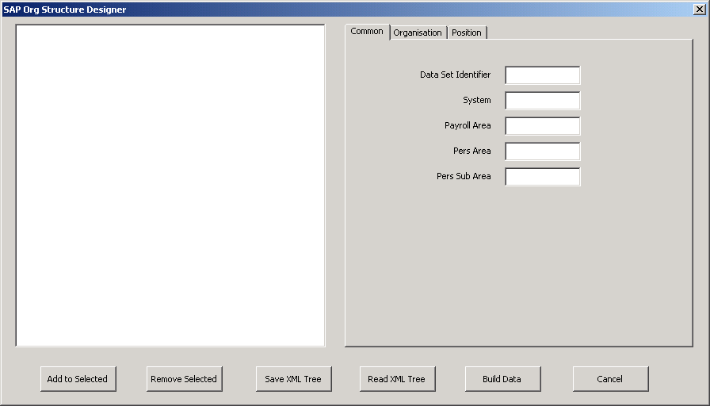

Figure

## Pane Description

### Tree view pane

Tree view displays the tree as, either:

* As the user builds it, or
* As rebuilt from a saved tree.

Figure 2 below shows a structure build for the Usability team, built with this tool.

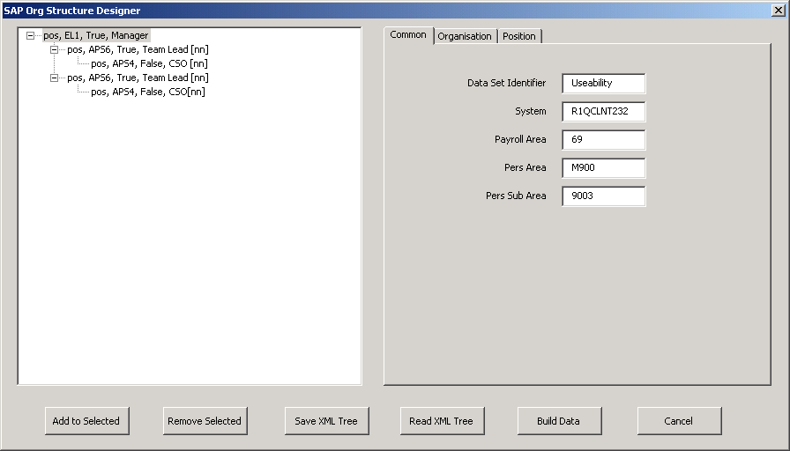

Figure – Sample Structure

The first node at the top of the tree is referred to as the root node.

### Data View Pane

Data view consists of a tabbed page which displays data but does not edit data from the selected node on the tree view pane. The tabs divide the view into specific items, being either common data, an Org or a Position.



Figure - Sample Common Data

Organisation and Position are read from and automatically activated base on the selected node, ie clicking on an Org node will activate the Organisation tab. The user is free to click on the tabs to activate a different tab.

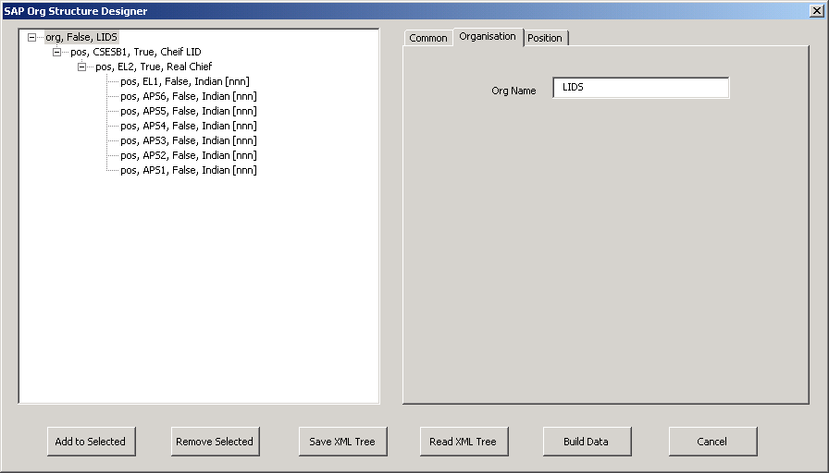

Figure - Sample Org Data

Position is a complete reproduction of the data collected, including the roles chosen for the user. See Figure 5 - Sample Position Data below.

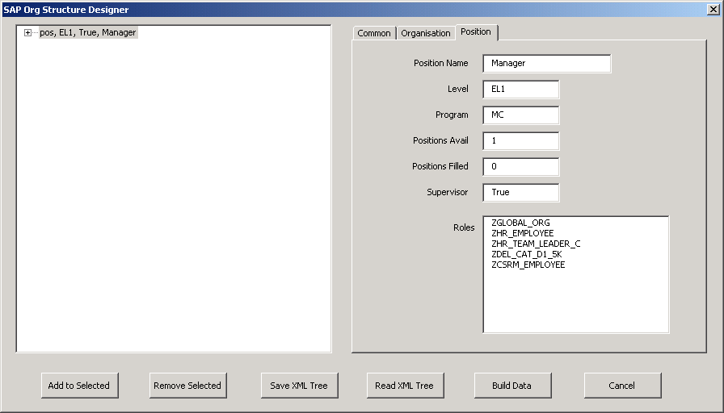

Figure - Sample Position Data

### Button Pane

The forms button pane is the control centre of the form; all available actions are initiated by clicking on the relevant button.



Figure

Buttons on the form serve specific functions described below:

* **Add to Selected**. In the case of an empty tree, Add creates the “root” node, or adds any new nodes to the node selected by the user. There is a dialog opened by this button to gather data from the user to create the node.
* **Remove Selected** deletes the selected node and all sub-nodes connected to the selected node. There are no actions available to undo a change once made.
* **Save XML Tree**. Saves the XML File by asking saving with a file name based on the initial data entered on the main forms node data “Common” tab.
* **Read XML Tree**. Opens a file selection dialog filtered to XML.
* **Build Data**. Creates a new sheet in the master excel sheet and populates data based on the tree in the Tree View pane.
* **Cancel**. Closes the form without saving the data out. Closing does not remove the data and reopening later (without closing the excel session) will still contain your tree.

## Using the form

The form consists of a few simple steps to build, save and create data for a new Org Structure. These are:

* Customer defines the structure
* work over the phone and a Sametime Meeting to build the structure in the tool
* Save XML Tree often during the build action to reduce risk of data loss.
* Time constraints may require you to stop the build process; the saved data is retrievable later. See Reading XML File below for details on retrieving the file later.
* When the completed structure is agreed upon, click Save XML Tree then build data.
* Your data and structure is now ready for data preparation.

### Define the structure

Let the customer define the structure, taking into account the design limitation for Orgs not being able to hold an org in this tool. Customers must know:

* What the structure looks like (hierarchical chart) in terms of Organization and Positions
* How many positions at each level, how many staff fill those positions
* Who is supervising who.
* What level each position will have.
* What Payroll, HR and workflow requirements are in their tests, including Personnel- and Personnel Sub- Areas (Pers Area, Pers Sub Area).
* What Security Roles each position needs for the tests.

### Build the structure

Start by populating the data on the Common tab as (see Figure 7 below):



Figure

* **Data Set Identifier** is to be a unique identifier in the spreadsheet and links the XML data file to the Test Tool execution.
* **System**. Target system identifier, for SAP is in the form R1TCLNT245, usually supplied by the customer or test team, where:
  + R1T is the system, and
  + 245 is the client
* **Payroll Area**. Values are usually supplied by the customer, with a value between 60 and 69 during testing. A test engineer may exercise discretion if the customer’s tests are not affected by the payroll area value.
* **Pers Area**. Short for Personnel Area, values are usually supplied by the customer. A test engineer may use discretion to pick a value if the customer’s tests are not affected by this value, with these caveats:
  + Pers Area and Pers Sub area are codes that link hired personnel to their HR office and take the Form H150, where H = Human Services Program. C = Centrelink and M = Medicare.
  + Ensure Pers Area is matched with Pay scale, ie Pers Area H150 must have a payscale equal to HS. Pay scale is set in the Default Data sheet in the spreadsheet.
  + Ensure the Pers Sub Area is a linked value with the Pers Area. Eg C300 will have a list of Pers Sub Aresa values ranging from 3000 to 3999, which can be manually identified on the target system while preparing data.
    - This is done by:
      * open a target system session and log in with a special automation user
      * Find any position from the structure search feature
      * Check the position has an Infotype 1005 Plan Compensation available
      * Edit that record and try changing values in Pay scale and the Pers Areas to help identity suitable values.
* **Pers Sub Area**. Is a linked value that should be manually confirmed from the test target (See how above). Usually the customers will define both values, but engineers may use discretion.

Build the structure tree by using buttons from the button pane (See Figure 8 below) to add a node; or remove one or more nodes. Select a node when you need to connect nodes to that one.



Figure

Repeat selecting the appropriate node, using the buttons and filling the dialogs until the structure is complete. You may optionally save the data at anytime during your structure build and retrieve at anytime in the future.

**Add to selected** opens the dialog in Figure 9 below. Each field collects information used to build the data table and structure and the user should work from top to bottom of the form and click OK when this is populated correctly.

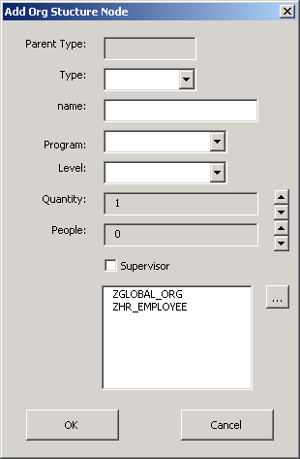

Figure

Field definitions are:

* **Parent Type**. Reads the parent node type. Will be blank on the first node or read the selected node type. Read Only.
* **Type**. Drop list – Choices are either Pos or Org. If the Parent is an Org, Pos is the only option.
* **Name**. Name of the Position or Org in the structure. There is an option to apply incrementing counts by adding [n] to the name where the n’s represent the field width, ie 3 digits wide is [nnn]. If not named, the position is a dummy and will not generate in the test tool during execution.
* **Program**. Drop List CL, MC or HS.
* **Level**. Drop List APS1 to SEC levels, varies based on the Program.
* **Quantity**. Number of positions at the level to be generated. Ranges from 1 to user driven value. Click the buttons to the right to “spin” up or down. Usually requested by the customer.
* **People**. Number of people to fill the positions in this node. Ranges from 0 to limit of positions set by the user. Usually requested by the customer.
* **Supervisor**. Check box, either true or false. Valid only when there is one position at the level defined and rendered invisible when position is greater than 1. The customer must specify where their supervisors are in the structure.
* **Roles**. Security roles for positions. The roles are derived from a report in the target system and stored in the spreadsheet. Click on the button to the right of the field with the dyadic(...) to access the complete listing. This should be supplied by the customers, especially where these affect permission for certain actions or workflows in the system.

Roles dialog in Figure 10 below allows the user to pick any role in the system. The list is stored in the master spreadsheet in the tab named “Security Roles”. The Technical Manual Chapter X describes how to obtain and maintain this data.

User attention is drawn to Figure 11 - Using Find below. Typing the first few characters auto-locates the entry at the bottom of the visible list. The interface used is limited to this functionality.

|  |  |
| --- | --- |
| Figure | Figure - Using Find |

If the user selects Org in Type, all fields except Name are rendered invisible. Like position, Org names also use the incrementing number mechanism for a quick way to unique name the organisations. Just add [n] to the name if you want that to be done. The number of n’s represents the **minimum** field width.

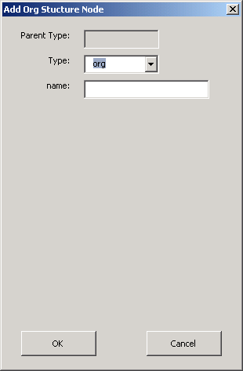

Figure – Choosing Org

### Build the Data

When the structure is completed:

* save the structure, and
* click Build Data

The data is now ready for preparation and exporting to the test tool.

### Reading XML File

Users clicking the Read XML File button will open the dialog in Figure 13 below. Use this dialog to find your files to open. This specific box has been filtered to only locate XML files for the structure builder.

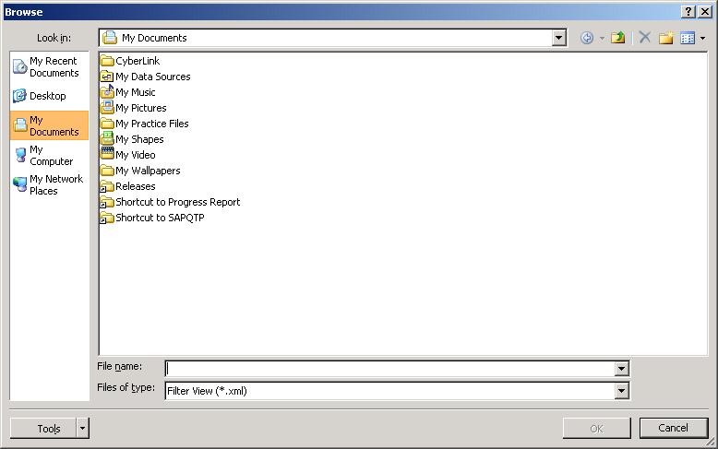

Figure - Standard File and Folder Browser Dialog box

...oooOOOooo...

1. Pane is the standard industry name for a sub-section of an interface in a windowed environment.